Nama : Erika Dwi Jayanti (211331006)
Partner : Tsaniya Faridah Maulida (211331031)
Kelas : 1A - TTE
Tanggal Praktikum : Kamis, 14 April 2022

JURNAL PRAKTIKUM ELEKTRONIKA DIGITAL
MULTIPLEXER - DEMULTIPLEXER

  - Tabel Persamaan
Tabel 1 Tabel Persamaan MUX
S | I₁ | I₀ | Y
0 | 0 | 0 | 0
0 | 0 | 1 | 1
0 | 1 | 0 | 0
0 | 1 | 1 | 1
1 | 0 | 0 | 0
1 | 0 | 1 | 0
1 | 1 | 0 | 1
1 | 1 | 1 | 1

S | I | Y₁ | Y₀
0 | 0 | 0 | 0
0 | 1 | 0 | 1
1 | 0 | 0 | 0
1 | 1 | 1 | 0
Tabel 2 Tabel Persamaan DEMUX

Tabel 3 Tabel Persamaan MUX-DEMUX
S_{M} | S_{D} | I₁ | I₀ | Y₁ | Y₀
0 | 0 | 0 | 0 | 0 | 0
0 | 0 | 0 | 1 | 0 | 1
0 | 0 | 1 | 0 | 0 | 0
0 | 0 | 1 | 1 | 0 | 1
0 | 1 | 0 | 0 | 0 | 0
0 | 1 | 0 | 1 | 1 | 0
0 | 1 | 1 | 0 | 1 | 0
0 | 1 | 1 | 1 | 0 | 0
1 | 0 | 0 | 0 | 0 | 0
1 | 0 | 0 | 1 | 0 | 0
1 | 0 | 1 | 0 | 0 | 1
1 | 0 | 1 | 1 | 0 | 1
1 | 1 | 0 | 0 | 0 | 0
1 | 1 | 0 | 1 | 0 | 0
1 | 1 | 1 | 0 | 1 | 0
1 | 1 | 1 | 1 | 1 | 0

  - Gambar Rangkaian

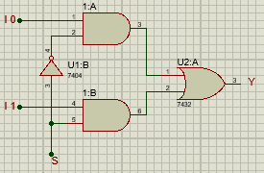
Gambar 1 Rangkaian Mux
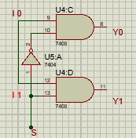
Gambar 2 Rangkaian Demux

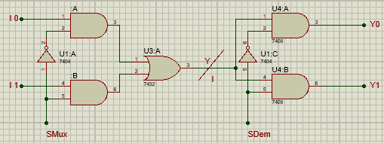
Gambar 3 Rangkaian Mux-Demux

  - Hasil Percobaan
Tabel 1 Hasil Percobaan Rangkaian Mux
S | I₁ | I₀ | Y | Foto
0 | 0 | 0 | 0 | 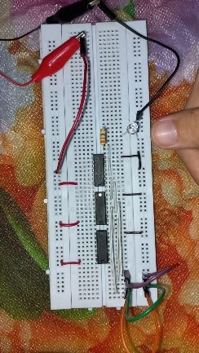
0 | 0 | 1 | 1 | 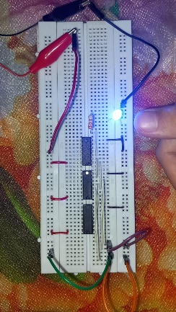
0 | 1 | 0 | 0 | 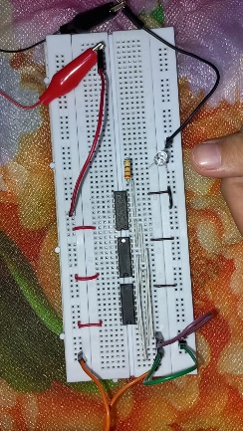
0 | 1 | 1 | 1 | 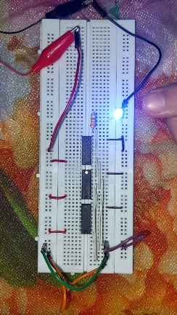
1 | 0 | 0 | 0 | 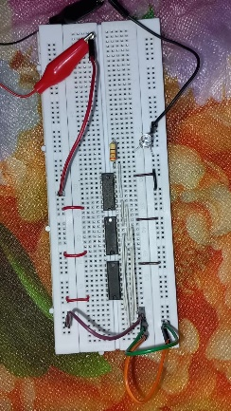
1 | 0 | 1 | 0 | 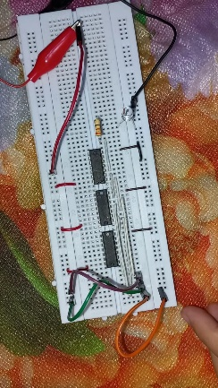
1 | 1 | 0 | 1 | 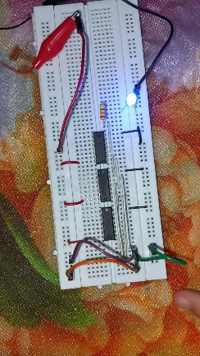
1 | 1 | 1 | 1 | 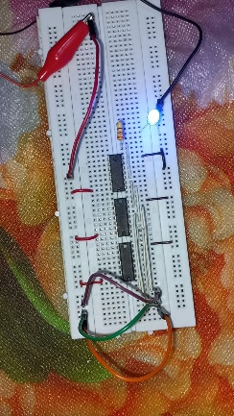

Tabel 2 Hasil Percobaan Rangkaian Demux

S | I | Y₁ | Y₀ | Foto
0 | 0 | 0 | 0 | 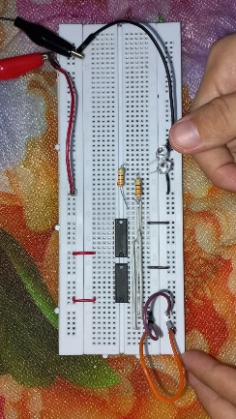
0 | 1 | 0 | 1 | 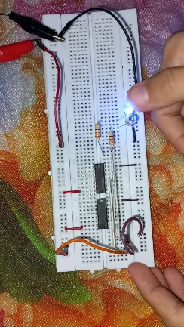
1 | 0 | 0 | 0 | 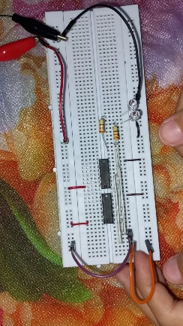
1 | 1 | 1 | 0 | 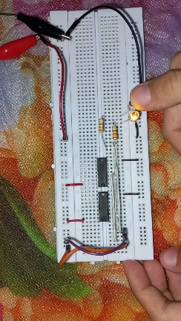

Tabel 3 Hasil Percobaan Rangkaian Mux-Demux
S_{M} | S_{D} | I₁ | I₀ | Y₁ | Y₀ | Foto
0 | 0 | 0 | 0 | 0 | 0 | 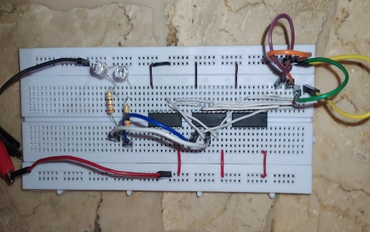
0 | 0 | 0 | 1 | 0 | 1 | 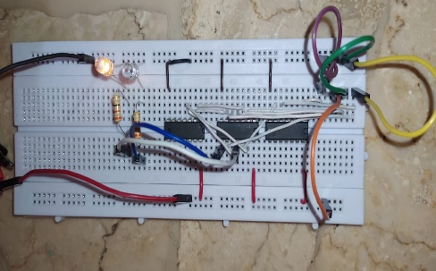
0 | 0 | 1 | 0 | 0 | 0 | 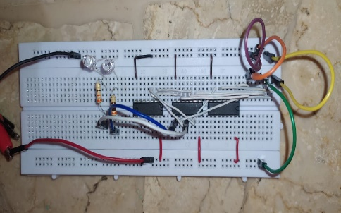
0 | 0 | 1 | 1 | 0 | 1 | 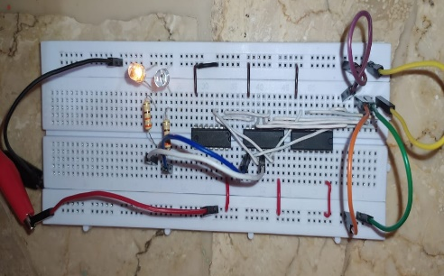
0 | 1 | 0 | 0 | 0 | 0 | 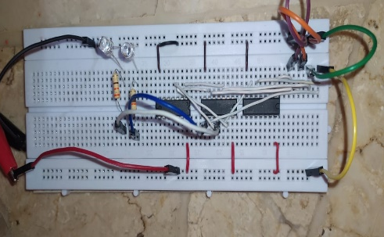
0 | 1 | 0 | 1 | 1 | 0 | 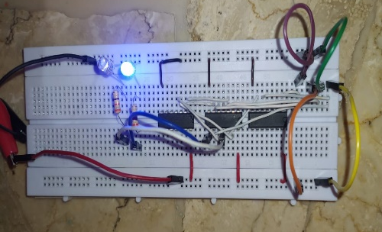
0 | 1 | 1 | 0 | 1 | 0 | 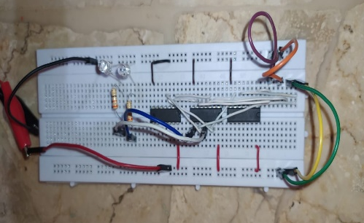
0 | 1 | 1 | 1 | 0 | 0 | 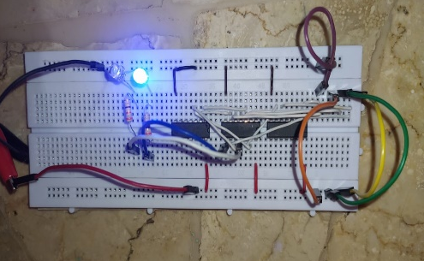
1 | 0 | 0 | 0 | 0 | 0 | 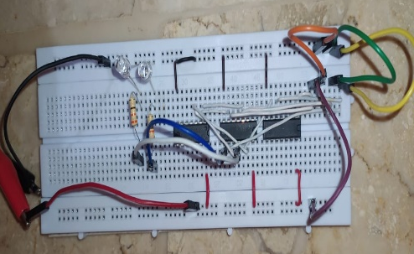
1 | 0 | 0 | 1 | 0 | 0 | 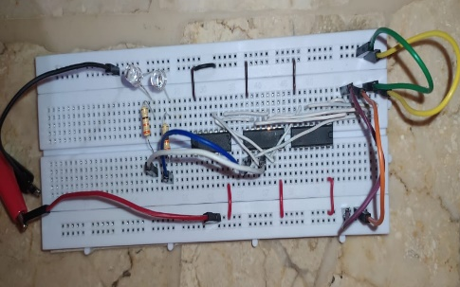
1 | 0 | 1 | 0 | 0 | 1 | 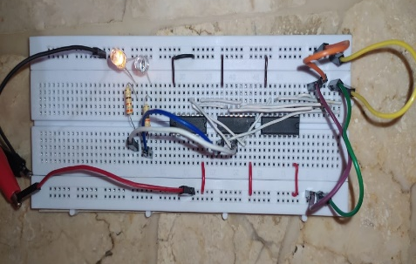
1 | 0 | 1 | 1 | 0 | 1 | 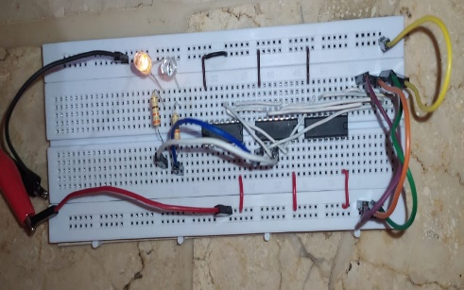
1 | 1 | 0 | 0 | 0 | 0 | 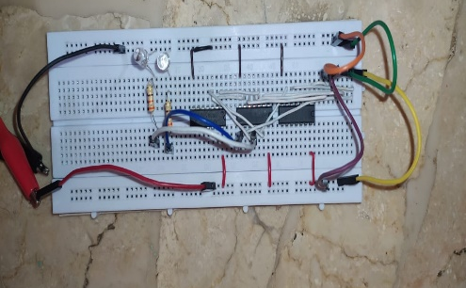
1 | 1 | 0 | 1 | 0 | 0 | 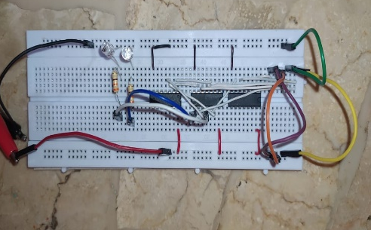
1 | 1 | 1 | 0 | 1 | 0 | 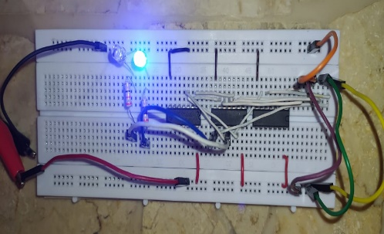
1 | 1 | 1 | 1 | 1 | 0 | 